**Team 5, Project 1 -** Jacob, David, George, Kennth, Matt

**Hypothesis**: Our team believes that US political news will be the most popular type of articles displayed in any time frame by the New York Times. However, upon further research into the genre types of articles available on the API primarily used, time constraints and financial limitations, we decided that the “U.S.” category would be the most popular out of the following types:

* Arts
* Business
* Climate
* Health
* Magazine
* Movies
* New York
* Opinion
* Sports
* Style
* Sunday Review
* Theater
* U.S.
* World

**Question 1: What is the most popular type of article?**

**Answer**: The combined most popular type of article is *Opinions*.

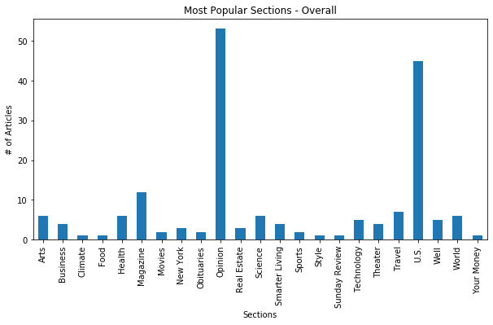

**Question 2: Does the most popular type of article change depending on the time frame used or does the most popular article remain constant from 1 Day through 30 Days?**

**Answer**: For “Shared” and “Emailed” the Opinions category remained constant despite of time frame. The same applied for the U.S. Category for the “Most Viewed”.

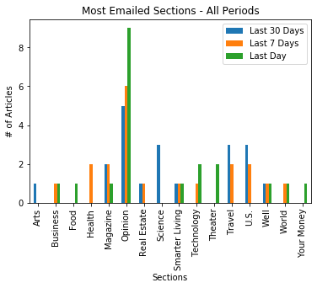

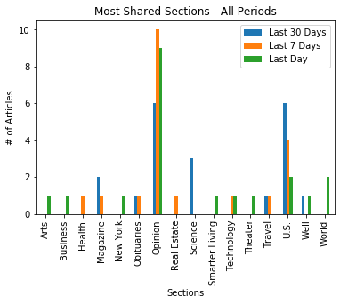

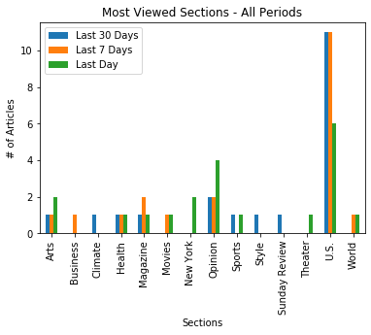

**Question 3: Are the same article types constantly the most viewed, shared and emailed?**

**Answer**: No. The most viewed article type was the U.S. news category. The Opinions category was both the most viewed and shared. *See above graphs for visualizations*.

The steps taken to produce and analyze the data once all dependencies were imported and the query url was identified were to pull json data from the “NYT Most Popular” API for the timeframes of 1 Day, 7 Days, and 30 Days. The most popular articles per time period were broken into the categories of “Most Emailed”, “Most Shared” and “Most Viewed”. Combining these categories with the time frames, and visualizing the data provided by the API, we were able to identify the overall “Most Popular Article Type”.

Our motivation to conduct this research was to solely find what the most popular news genre is according to one of the most prominent news sources in the contemporary world. Philosophically, we wondered if topical pseudo-news (i.e. Style and Health gossip), were as popular as more conventional article genres (i.e. U.S. domestic news and World News) and strived to support this with data.

**Findings**: Ultimately, after analyzing the data provided by the API primarily used and visualizing multiple graphs, our hypothesis was proven only true in the most viewed category. The most shared, emailed and ultimately most popular type of articles were that belonging to the Opinion category. However, the data is time specific. In order to properly display and analyze the data, we would have to decide on a set research time window and automate/iterate a loop to return the daily data and reassess. What is held to be true now or at the time of the research conducted could very well be drastically different in 1 month, 1 year, etc.

**Implications**: The implications produced by our findings after completing this project appear to be somewhat unclear. We can deduce that people in modern America (under the assumption that the majority of New York Times readers are American) are more interested in sharing the opinions of others than facts reported. This may be due to an increase in social media popularity and the ease in which readers can now disseminate information over the internet. The most viewed category is still a positive note though. Article topics that may produce little domestic and global effect (and have significantly less informative value) were substantially less viewed than what we as a group determined as more valuable and less vapid news. Depending on the personal opinions of the researcher or consumer of this data, one may believe that the end-user of the New York Times is prioritizing contemporary news accordingly. With the increase of social media consumption, reality tv and fabricated news sources, it is ultimately rewarding to find that contemporary news genres that deliver worth and education to the masses are still the most primarily viewed. It would be interesting to conduct this analysis again in the future to see if the most shared, emailed and viewed articles becomes unified under one article type. We can only assume that the exponential growth in technological communications and ability to share information will sway that to be true eventually.